Task 3: Probability and Congestion Analysis
Define congestion as: traffic volume > 5,500 vehicles.
Calculate:
3.1 Basic probability
- P(Congestion)
- P(Clear Weather)
- P(Congestion AND Clear Weather)
3.2 Conditional probability
Calculate:
- P(Clear Weather | Congestion)
- P(High Temperature | Congestion), where high temperature > 292K
- Determine whether weather conditions and congestion can be considered independent using P(A ∩ B) = P(A) × P(B)
- Calculate the odds ratio of congestion in clear versus cloudy weather.
Conclude with a short explanation of what the probability analysis suggests about the relationship between weather and congestion.

Solution:
I solved this using SQL queries but while the output was the same, it was quite difficult to understand, review and reuse. So I switched to using Power BI instead, with notes against all the cards for ease of understanding.
Screenshot from the dashboard built for this (I have also attached the actual file):
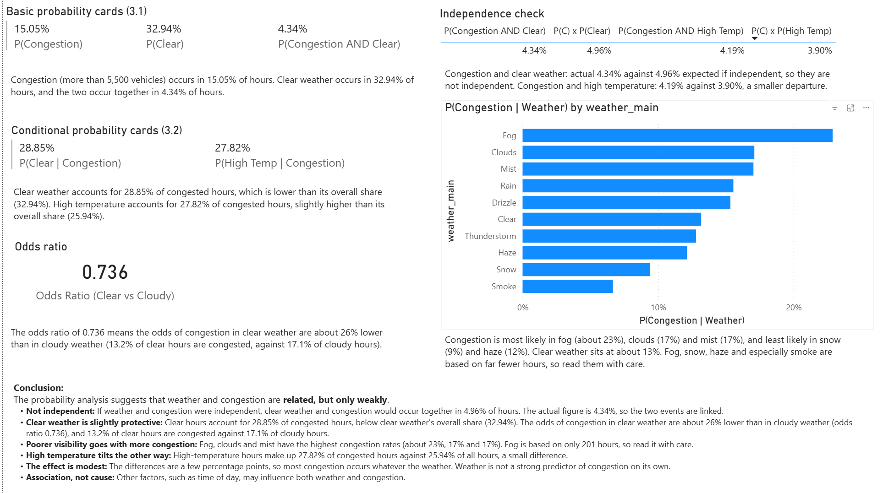
Conclusion:
The probability analysis suggests that weather and congestion are related, but only weakly.
- Not independent: If weather and congestion were independent, clear weather and congestion would occur together in 4.96% of hours. The actual figure is 4.34%, so the two events are linked.
- Clear weather is slightly protective: Clear hours account for 28.85% of congested hours, below clear weather’s overall share (32.94%). The odds of congestion in clear weather are about 26% lower than in cloudy weather (odds ratio 0.736), and 13.2% of clear hours are congested against 17.1% of cloudy hours.
- Poorer visibility goes with more congestion: Fog, clouds and mist have the highest congestion rates (about 23%, 17% and 17%). Fog is based on only 201 hours, so read it with care.
- High temperature tilts the other way: High-temperature hours make up 27.82% of congested hours against 25.94% of all hours, a small difference.
- The effect is modest: The differences are a few percentage points, so most congestion occurs whatever the weather. Weather is not a strong predictor of congestion on its own.
- Association, not cause: Other factors, such as time of day, may influence both weather and congestion.

